AccuPower® Customized service Order Form
Date
Sales Representative

*Required □ Customer Consultation and Order Review □ Order Confirmation
Customer Information*
Name |  | Phone Number
Organization |  | Email
Address

Order Information*
Product Type |  | □ PreMix type □ Master Mix type □ IRON-qPCR type
□ PCR □ RT-PCR □ qPCR □ RT-qPCR
□ IRON-qPCR (qPCR) □ IRON-qPCR (RT-qPCR)
Product Name (Cat. No):
* If product recommendation are needed, please indicate as “Recommendation.”
* If composition modifications are required instead of the existing method, please provide the composition separately.
Primer |  | □ No primer needed □ Primer included □ Primer Optimize required  * For Multiplex PCR, primer information can be attached separately.  * For IRON-qPCR, primer concentration cannot be set, and up to 5-plex is possible per well.
  Primer Name | Sequence | Concentration (pmole)
Target Name |  |  |  |  | Target Size (bp)
PCR Equipment
Tube type | Tube | □ 0.2ml thin-wall 8-strip tubes with attached caps  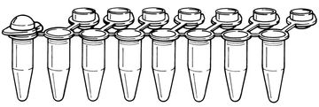  □ 0.2ml thin-wall tube with a flat cap  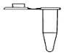  □ 0.5ml thin-wall tube with a flat cap  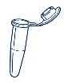 |  |  |  | □ 0.2ml thin-wall 8-strip tubes  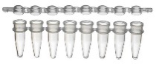  □ 0.2ml thin-wall tube with a dome cap  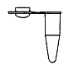  □ 0.5ml thin-wall tube with a dome cap  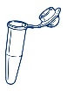
Tube type | Tube | * For qPCR PreMix, tubes compatible with the instrument will be provided  (For Exicycler™, QuantStudio Real-Time PCR and CFX instruments, tubes can be provided. For other instruments, customers are required to provide their own tubes.)
Tube type | 96-well plate | □ Full-skirted  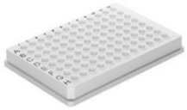 |  | □ Semi-skirted  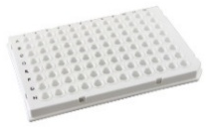 |  |  | □ Non-skirted  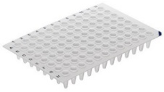
Tube type | IRON-qPCR | □ Cartridge with 4 channel plate  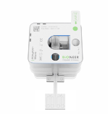 |  |  |  | □ Cartridge with 8 channel plate  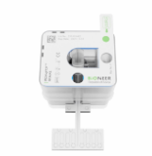
Tube type | Etc. | Manufacturer: |  |  |  | Cat. No:
Rxn Volume |  | □ 10ul □ 20ul □ 25ul □ 50ul □ etc. ( ul)  * IRON-qPCR: Fixed at 20 μl per well.
Order Quantity |  | PreMix type | □ 96 tubes □ 480 tubes □ etc. ( )
 |  | Master Mix type | □ 100 tests □ etc. ( )
 |  | IRON-qPCR type | Provided as 20 tests (= 20 cartridges) per kit.
 |  | Kit
Additional Requests
(Option)

Product Quality Control(QC)*
1. Party responsible for product QC after production | □ BIONEER □ Customer □ No product QC performed
2. If the Customer conducts the product QC, a Sample Kit will be provided.  * This applies when only the Customer requires QC or when it is difficult to provide the template and protocol. In this case, after the Customer completes the verification of the Sample Kit without BIONEER QC, the final product will be supplied. |  |  | □ Confirmed
3. If product QC is to be conducted by BIONEER,
3.1 Please provide the information required for testing (methods, reaction conditions, pass/fail criteria, etc.).
* File attachment is possible.
→

3.2 Method of providing template  * If the template is included in the kit, this does not apply.  * If synthesized by BIONEER, additional costs and lead time may apply. |  | □ Provided by Customer  □ Synthesized by BIONEER
3.3 Customer’s request for Sample Kit |  | □ Yes □ No
3.4 Method of providing product QC results |  | □ Certificate of Analysis (CoA) provided  □ Not provided
Customer Agreement* (Required upon order confirmation)
Customer Feedback | year month day Name (sign)

Payment Information
Credit Card |  | Purchase Order
Card Type | □ Visa □ Master | PO No.
Card Holder |  | PO No.
Card Number |  | PO No.
CSV Code |  | PO No.

* You can receive a quotation through your sales representative.

AccuPower® Customized service Term and Conditions of Sale

By signing this contract, you agree to the following terms and conditions.
In these terms and conditions below, “Customer” refers to the purchaser of the service/product, and “Bioneer” refers to the provider of the service/product.

- By signing this contract, the Customer agrees that the order will be confirmed without any changes to the order information, and that no changes will be allowed thereafter.
- If the Customer requests a Sample Kit, Bioneer will provide the Sample Kit according to the product specifications stated in the AccuPower® Customized service order form. After the Customer’s verification of the sample is complete, the final product will be manufactured.
- The Customer agrees to pay according to the pricing structure specified in the provided quotation.
- The estimated delivery date for the final product is 20 business days from the order confirmation date.
- Bioneer agrees to maintain all confidential information, including sequence information and order conditions described in the AccuPower® Customized service order form, as confidential for 7 years from the date such information is disclosed to Bioneer. Such information will not be used for any purpose other than business with the Customer and will be disclosed only to specific officers, directors, or employees who need to know. Bioneer will not disclose, publish, or divulge any confidential information received from the Customer to any third party without the Customer’s prior written consent.
- Bioneer will provide the product at the price specified in the quotation without any additional changes, and any requests outside the scope of the order conditions may incur additional costs.
- The Customer agrees to indemnify and hold Bioneer harmless from any and all claims, losses, costs, damages, or liabilities (including attorney's fees and other additional expenses) arising from the resale of AccuPower® Customized products.
- The scope of this contract does not exceed the terms and conditions specified herein.

By signing this contract, the Customer is deemed to have agreed to the terms and conditions.

Date | Name | Signature

